**EPICS Gateway configuration**

The configuration of all EPICS Gateway is stored and managed inside the inventory (https://inventory.psi.ch). Search the gateway simply by typing the name of the gateway and you should get the resulting part.

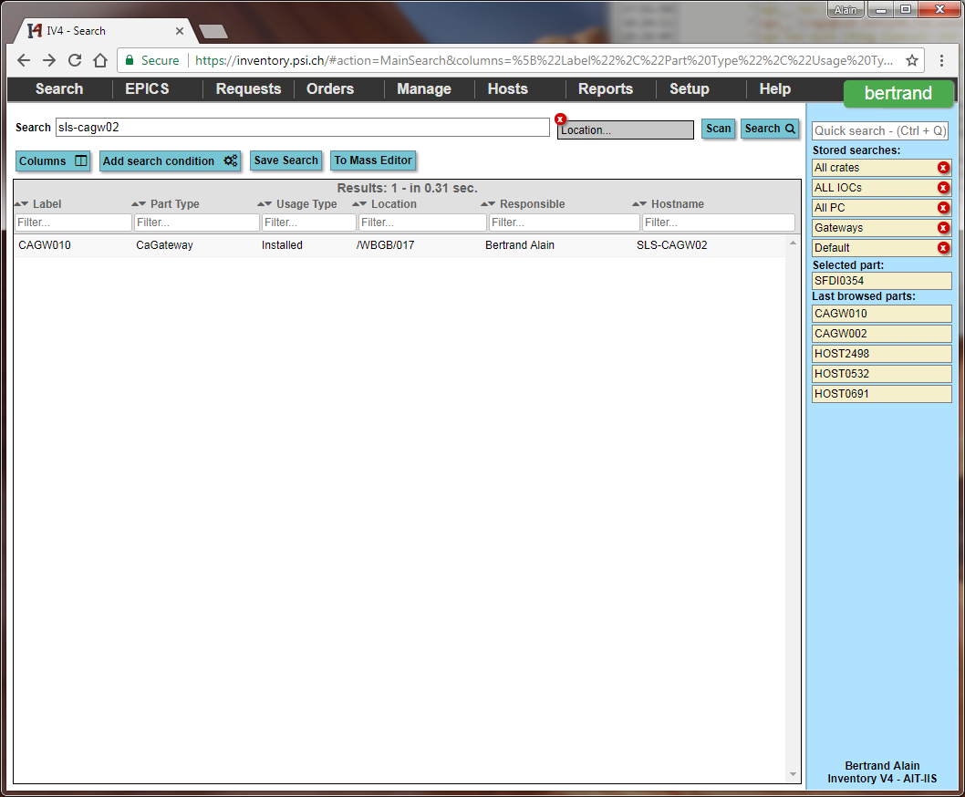

If you don’t see the “Hostname” field (and therefore don’t see if that’s the gateway you want to manage), click on the “Columns” button, type “Hostname” in the small text field under the field list and click on the “Hostname” field in the list.

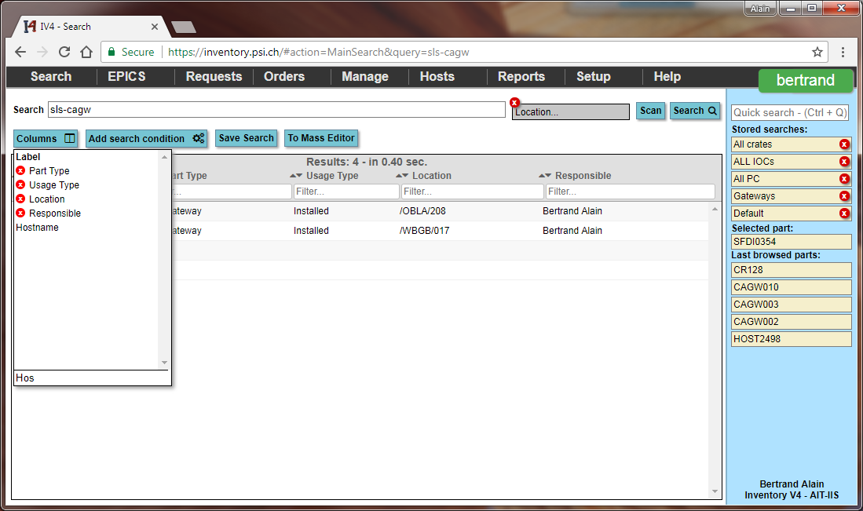

The first screen of the gateway configuration will display the access rules on top and the general configuration on the “Attribute” tab under.

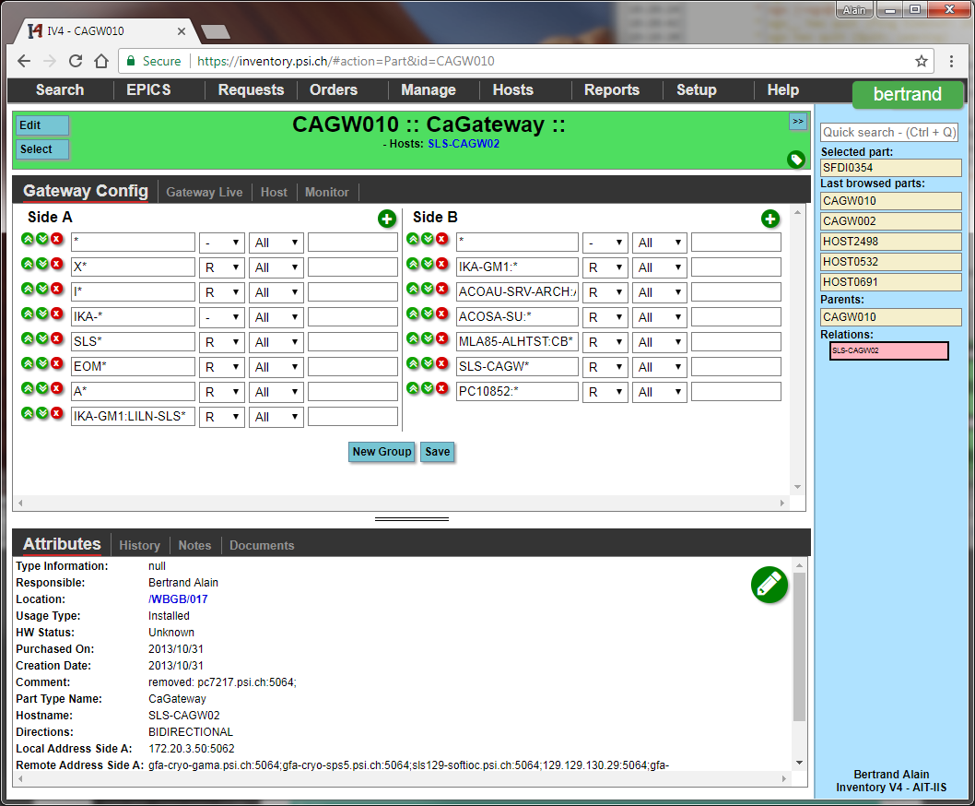

Most gateways are configured as “BIDIRECTIONAL” which means the gateway will work in both directions.

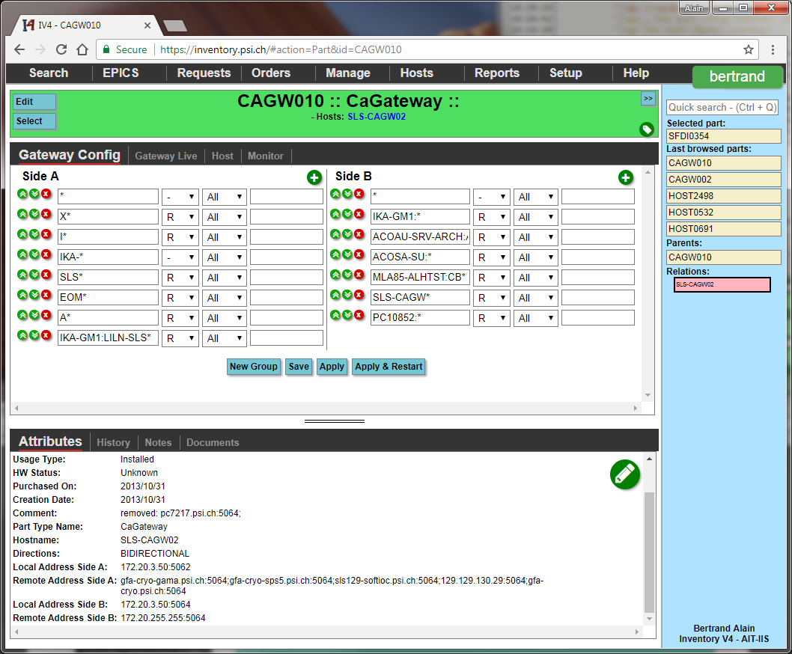

To understand which side is “Side A” and which one is “Side B”, check the attributes and look at the “Local Address” of the corresponding side.

In this example the “Side A” is 172.20.3.50:5062 and respectively “Side B” is “172.20.3.50:5064”. The access rules must be read as following. If you come from “Side A” and go to “Side B” then it’s the “Side A” column which applies to you. In the other direction then it’s the other column which applies. Think about which side you are going from and that’s the column you much check.

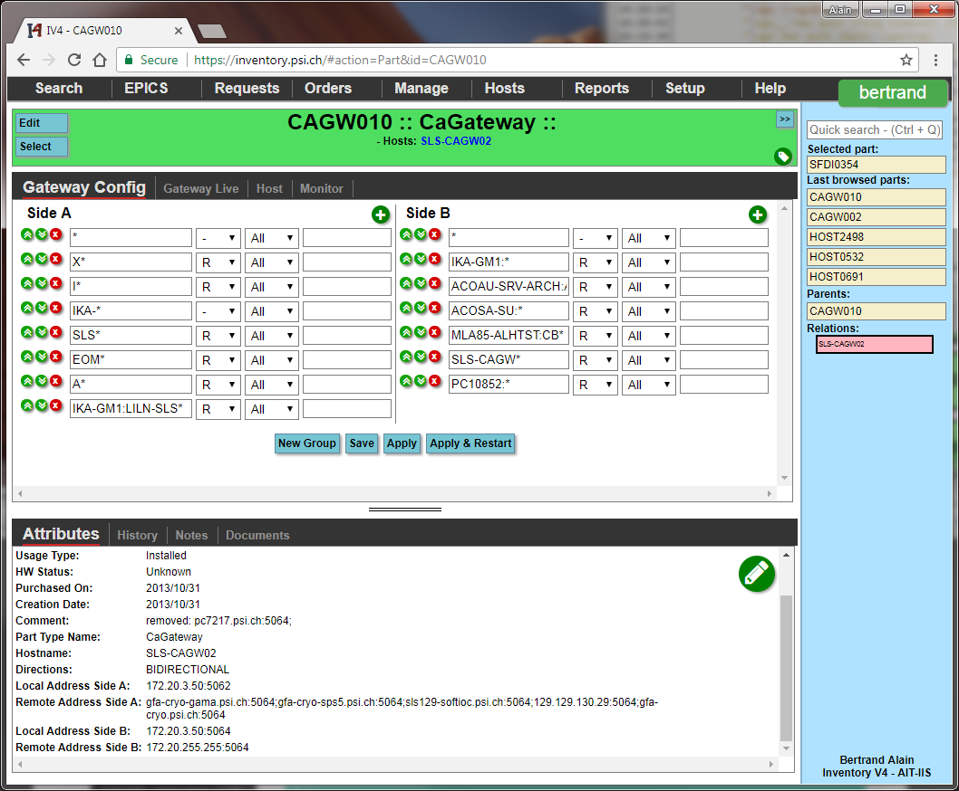

**Coming from Side B**

**Coming from Side A**

Entries order is also important as the last rules which can apply will define the access right. For example here we have a first row deny all (* no read write), then we have the rule X* read which means if the channel starts with an X have the right to read.

Rows can be moved up and down with the little green buttons and removed with the red x button.

To add new rules click on the “+” green button on top of the column and a new row will be added at the bottom.

The rules are split in 4 columns:

1. The first column is a regular expression matching channel’s names. 2 differences apply compared to standard regular expressions: a dot “.” is interpreted as a dot and the star “*” means any number of any characters.
2. The second column gives the access right for those channels from none, to read/write.
3. The 3rd column defines if this rules applies to all or only to some IPs (129.129.* would apply to any machine with IP starting with 129.129) or some Hostname.
4. The last column contains then the IP or the Hostname (without domain name) to filter.

In case a same set of channel filters needs to be applied to multiple hosts, the best solution is to use a group. To create a new group, click the “New group” button at the bottom. A group has a name (just as information), a set of filters, and a set of rules. The group will be evaluated if any of the filters (being IP or Host) match. If the filter set is match then the rules will be applied. For example we can give a set of consoles the right to write some channels.

**Note:** As long as you don’t press the save button none of the changes you made will be stored.

By clicking the “Gateway Live” tab an overview of the state of the gateway is available, as well as more debug information like who searches what.

The stats are all read through EPICS can be monitored with the usual EPICS tools (being panels or archiver).

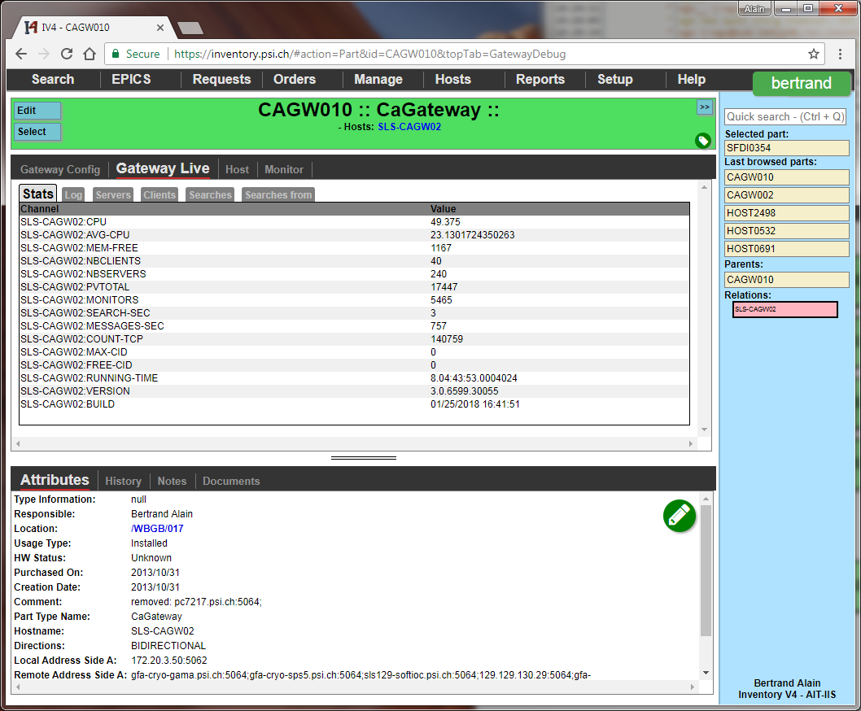

The “Monitor” tab allows you to subscribe to the active monitoring offered by the Inventory software. If you subscribe to it, you will receive emails every time a gateway is not anymore reachable.

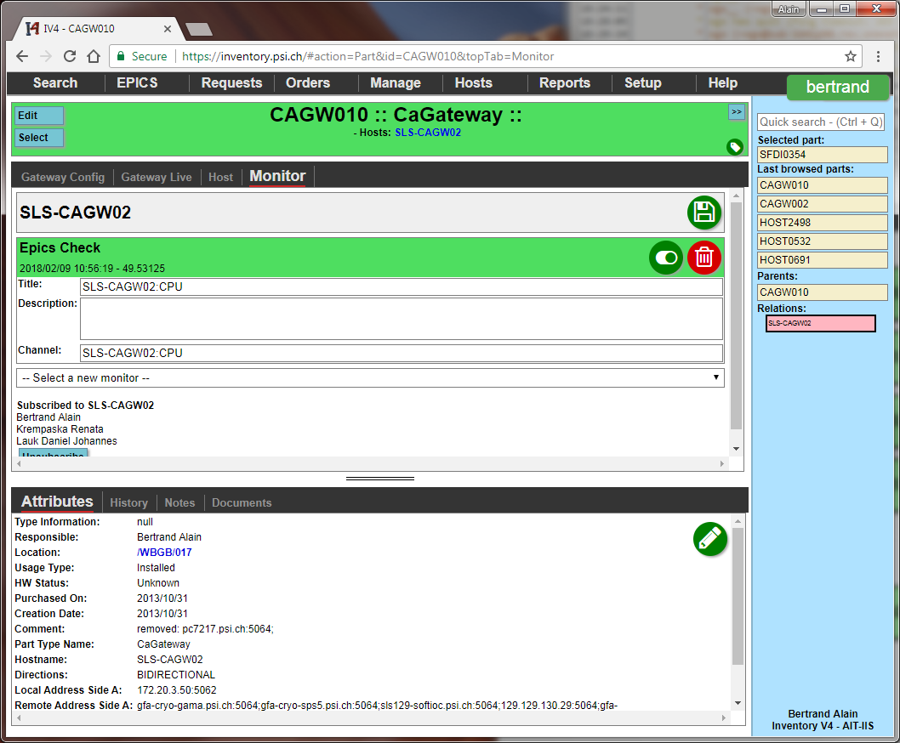

The gateway configuration is loaded only during the restart of the service, therefore even if you save a new configuration the gateway will not directly have the new rules applied. To apply them use the inventor y “Manage” tab.

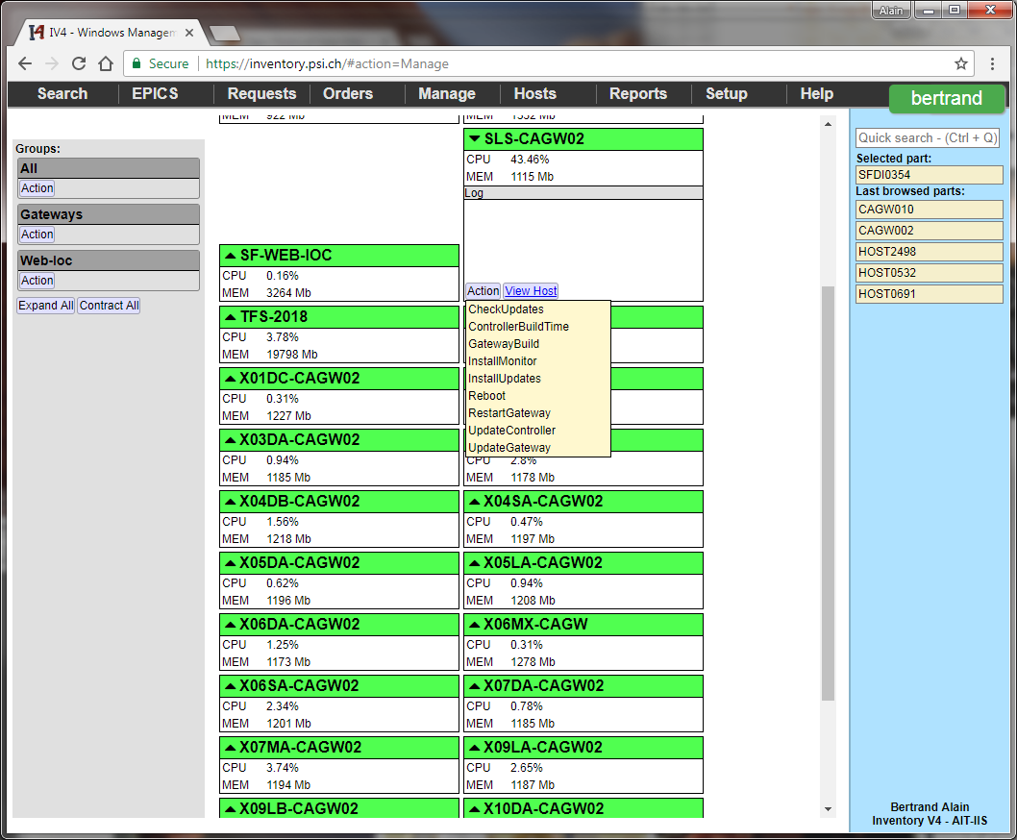

You will see there all the gateways you can manage. Expanding a gateway (by clicking on the name of the gateway) will show a Log (usually empty) and 2 buttons. The action button let you restart remotely the gateway service or reboot the virtual machine for example. Usually only the “RestartGateway” entry should be used. In case of issues with the gateway the same procedure can be used to have a clean state of the service.

A real time monitoring of the gateway is also available through the site: http://iv-mon.psi.ch allowing a quick overview of all the running gateways. If the page is left open errors will be signalized via a sound as well as a browser alert.

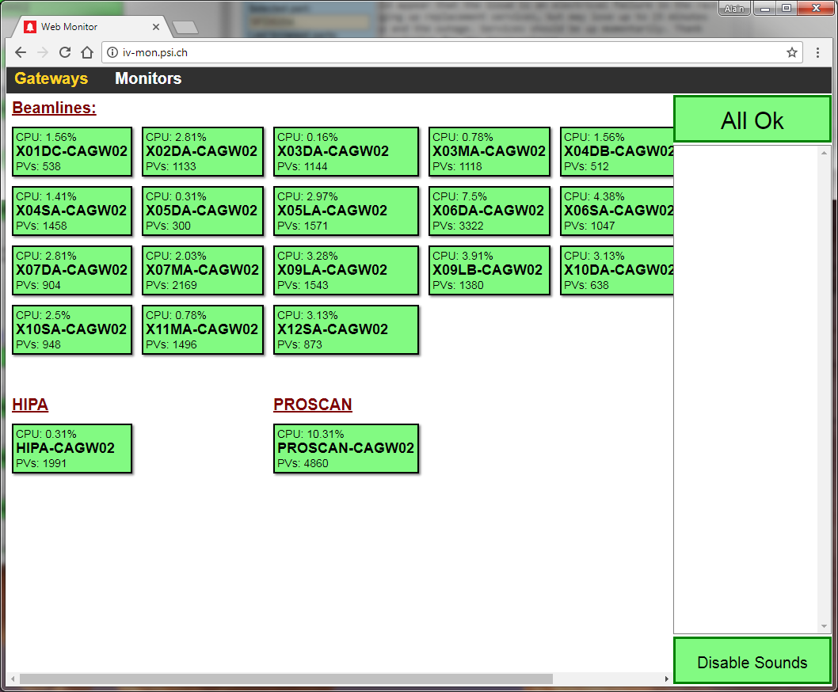

By clicking one of the gateways a more detailed view of the service as well as 2 real time graphs are displayed.

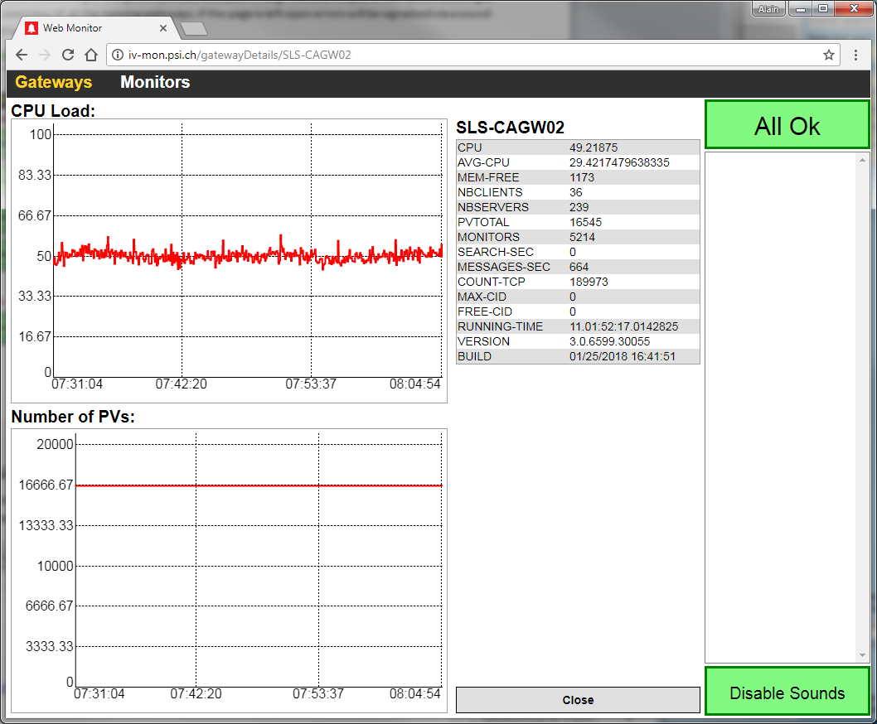

Errors can be acknowledge by clicking the “Error” button which replace the “All Ok” button on the top right corner of the page.

A log of all the gateways reloads is available inside the inventory under “Hosts” => “Gateways Log”

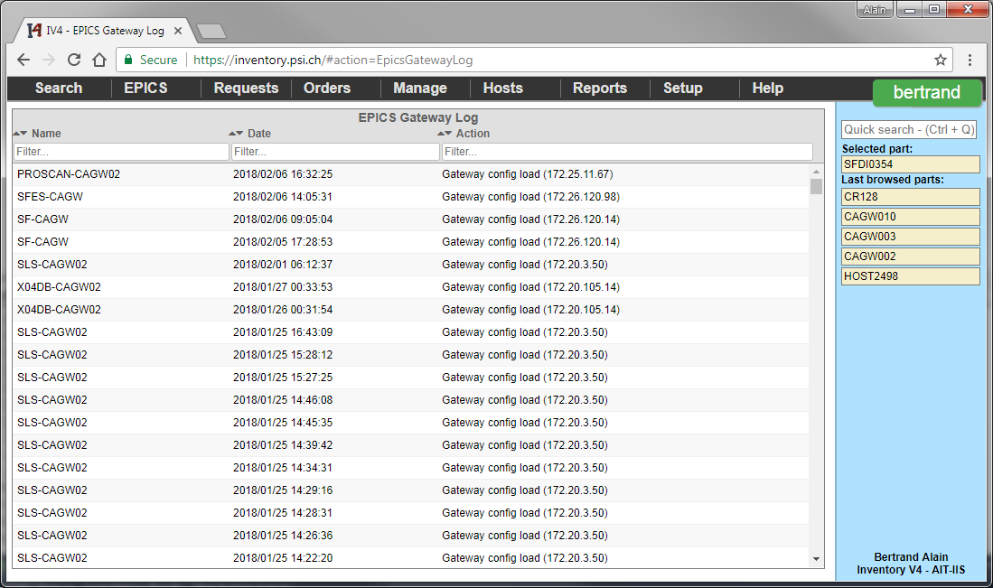

Using the same table it’s possible to generate reports about how often the different gateway restart. Use the “Reports” => “Database design” page and enter the following query:

SELECT GatewayName, NB/NBMonths "AvgReloadMonths" FROM

(SELECT DATEDIFF(MONTH,"Min","Max") "NBMonths",NB,GatewayName FROM

(SELECT MIN(EntryDate) "Min", MAX(EntryDate) "Max", COUNT(*) "NB", GatewayName

FROM GatewayLogs WHERE FORMAT(EntryDate,'MM') != '01' GROUP BY GatewayName) AS "Q1") "Q2"

WHERE NBMonths > 0 AND GatewayName NOT IN ('PBGW','X09LB-CAGWTEST') ORDER BY GatewayName

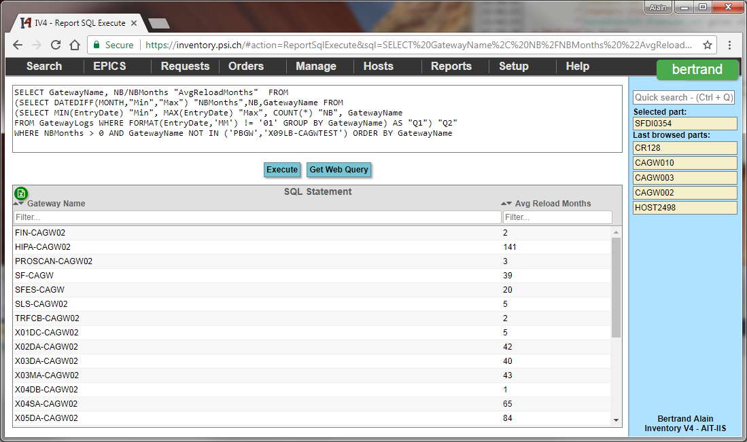

The query will make an average of how many reloads we have per month for each gateway. We filter out January from the report due to the shutdown (and multiple restarts due to the watchdog).

The query:

SELECT COUNT(*) "NB Reloads", Months FROM

(SELECT FORMAT(EntryDate,'yyyy\.MM') "Months" FROM GatewayLogs WHERE GatewayName = 'SLS-CAGW02') "Q1"

GROUP BY Months

ORDER BY Months

Answer how many reloads we have each months for the gateway “SLS-CAGW02”.